Bahria University,

Karachi Campus

LAB EXPERIMENT NO.

_______4_______

LIST OF TASKS

|  |  |
| --- | --- |
| TASK NO | OBJECTIVE |
| 1 | **Create an application which can display a Toast message by pressing a button.** |
| 2 | **Create an application having three buttons. Bind those buttons with the same callback method. On pressing any button, identify which button was pressed.** |
| 3 | **Create an application which takes a string message from user and create a toast of it on pressing button.** |
| 4 | **Create a calculator application for two integers.** |

Submitted On:

___________

(Date: 5/4/23)

### 

### LAB NO:04

**Task # 1:** Create an application which can display a Toast message by pressing a button.

**.java code:**

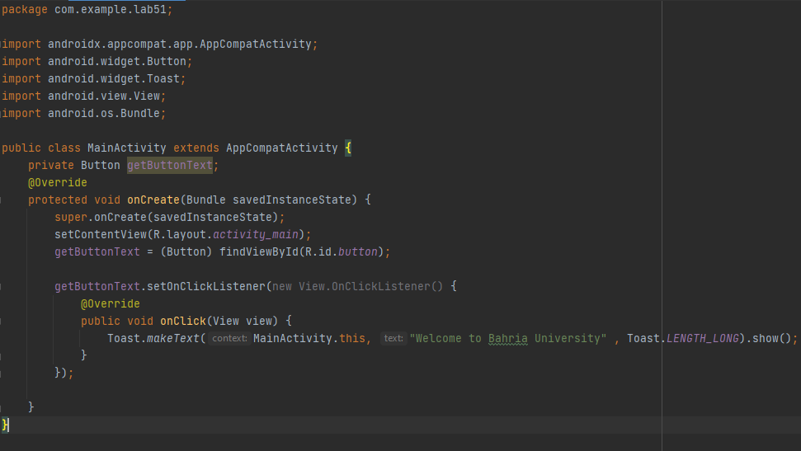

**.xml code:**

<?xml version="1.0" encoding="utf-8"?>  
<androidx.constraintlayout.widget.ConstraintLayout xmlns:android="http://schemas.android.com/apk/res/android"  
 xmlns:app="http://schemas.android.com/apk/res-auto"  
 xmlns:tools="http://schemas.android.com/tools"  
 android:layout_width="match_parent"  
 android:layout_height="match_parent"  
 tools:context=".MainActivity">  
  
 <Button  
 android:id="@+id/button"  
 android:layout_width="wrap_content"  
 android:layout_height="wrap_content"  
 android:layout_marginTop="16dp"  
 android:text="Bahria University"  
 app:layout_constraintEnd_toEndOf="parent"  
 app:layout_constraintHorizontal_bias="0.262"  
 app:layout_constraintStart_toStartOf="parent"  
 app:layout_constraintTop_toTopOf="parent" />  
  
</androidx.constraintlayout.widget.ConstraintLayout>

**OUTPUT:**

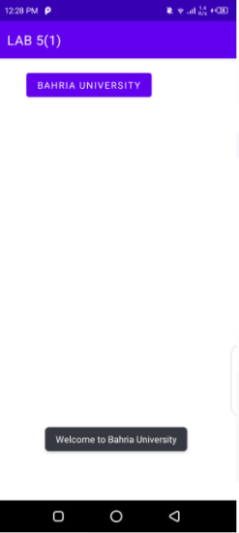

**Task # 2:** Create an application having three buttons. Bind those buttons with the same callback method. On pressing any button, identify which button was pressed.

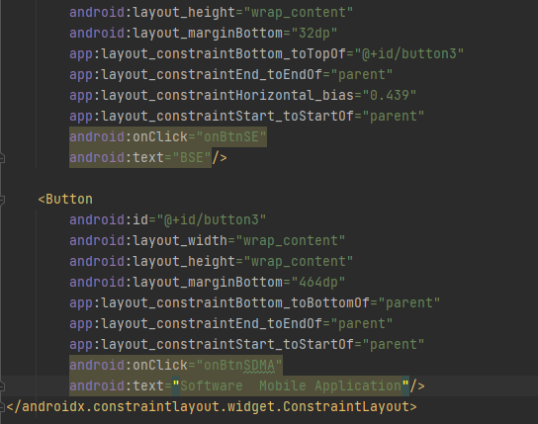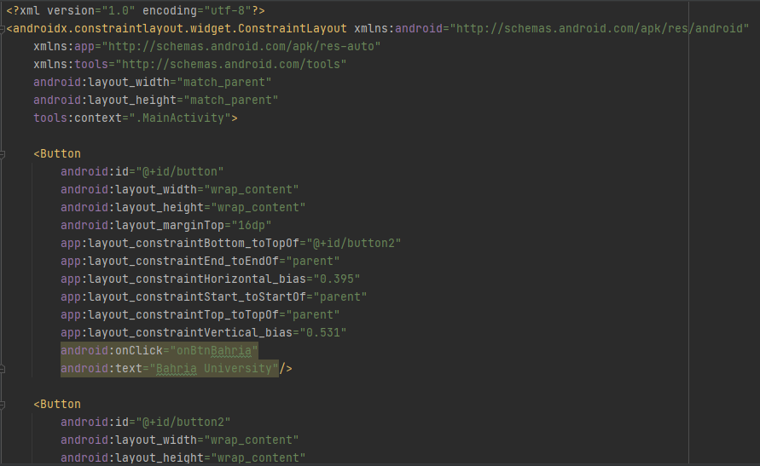**.xml code:**

**.java code:**

package com.example.lab51;  
  
import androidx.appcompat.app.AppCompatActivity;  
import android.widget.Button;  
import android.widget.Toast;  
import android.view.View;  
import android.os.Bundle;  
  
public class MainActivity extends AppCompatActivity {  
 private Button getButtonText;  
 @Override  
 protected void onCreate(Bundle savedInstanceState) {  
 super.onCreate(savedInstanceState);  
 setContentView(R.layout.*activity_main*);  
  
 }  
 public void onBtnBahria(View view) {  
 Toast.*makeText*(getApplicationContext(), "BAHRIA...", Toast.*LENGTH_SHORT*).show();  
 }  
  
 public void onBtnSE(View view) {  
 Toast.*makeText*(getApplicationContext(), "Software Department ...", Toast.*LENGTH_SHORT*).show();  
 }  
 public void onBtnSDMA(View view) {  
 Toast.*makeText*(getApplicationContext(), "Software Application and Mobile Device ...", Toast.*LENGTH_SHORT*).show();  
 }  
}

**Output:**

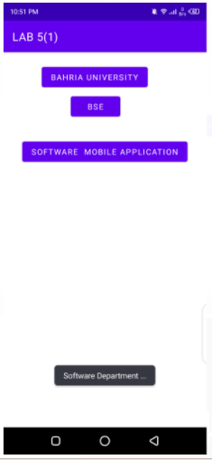

**Task # 3: Create an application which takes a string message from user and create a toast of it on pressing button.**

**Solution:**

**Design:**

**Code:**

public class MainActivity extends AppCompatActivity {

    private Button btn;

    private EditText txt;

    @SuppressLint("MissingInflatedId")

    @Override

    protected void onCreate(Bundle savedInstanceState) {

        super.onCreate(savedInstanceState);

        setContentView(R.layout.activity_main);

        btn=findViewById(R.id.button4);

        txt=findViewById(R.id.editTextTextPersonName);

        btn.setOnClickListener(new View.OnClickListener() {

            @Override

            public void onClick(View view) {

                Toast.makeText(MainActivity.this, ""+txt.getText(), Toast.LENGTH_SHORT).show();

            }

        });    }

}

1. Create a calculator application for two integers. The output must look as follows

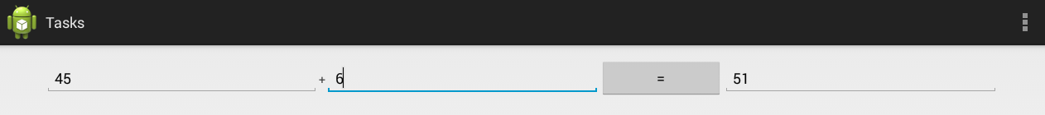

**.xml code:**

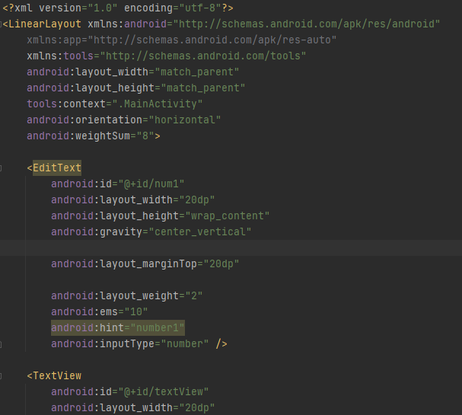

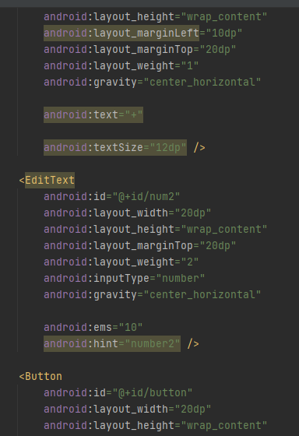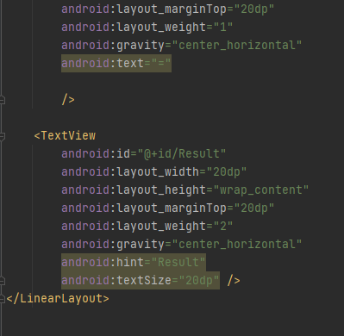

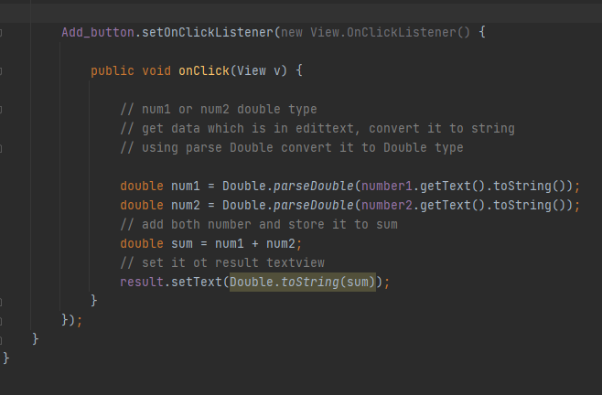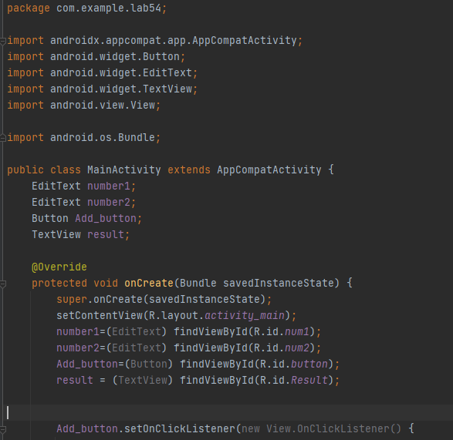**.java code:**

**Output:**

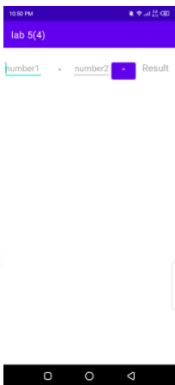 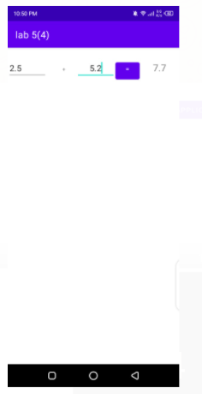

**Task # 4: Create a calculator application for two integers.**

**Solution:**

**Design:**

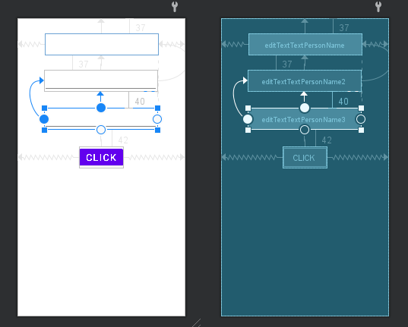

**Code:**

public class MainActivity extends AppCompatActivity {

    private Button btn;

    private EditText txt;

    private EditText txt2;

    private EditText txt3;

    @SuppressLint("MissingInflatedId")

    @Override

    protected void onCreate(Bundle savedInstanceState) {

        super.onCreate(savedInstanceState);

        setContentView(R.layout.activity_main);

        btn=findViewById(R.id.button4);

        txt=findViewById(R.id.editTextTextPersonName);

        txt2=findViewById(R.id.editTextTextPersonName2);

        txt3=findViewById(R.id.editTextTextPersonName3);

        btn.setOnClickListener(new View.OnClickListener() {

            @Override

            public void onClick(View view) {

                btn.setOnClickListener(new View.OnClickListener() {

                    @Override

                    public void onClick(View view) {

                        int num1=Integer.parseInt(""+txt.getText());

                        int num2=Integer.parseInt(""+txt2.getText());

                        int res=num1+num2;

                        txt3.setText(""+res);

                    }             });            }

        });

    }

}

**Output:**

